**St John the Baptist, Small Hythe**

A short way from the historic town of Tenterden lies the village of Small Hythe.[1] This small village, although now completely landlocked, had close ties to the Cinque Ports Confederation. Small Hythe was a famous shipyard in medieval times, using timber from the great Wealden Forest. Although it is difficult to imagine when looking at the modern landscape of Kent, the county used to be an archipelago of deep channels and small isles, the names of which exist to this day, such as the Isle of Thanet, and Small Hythe’s neighbour the Isle of Oxney.

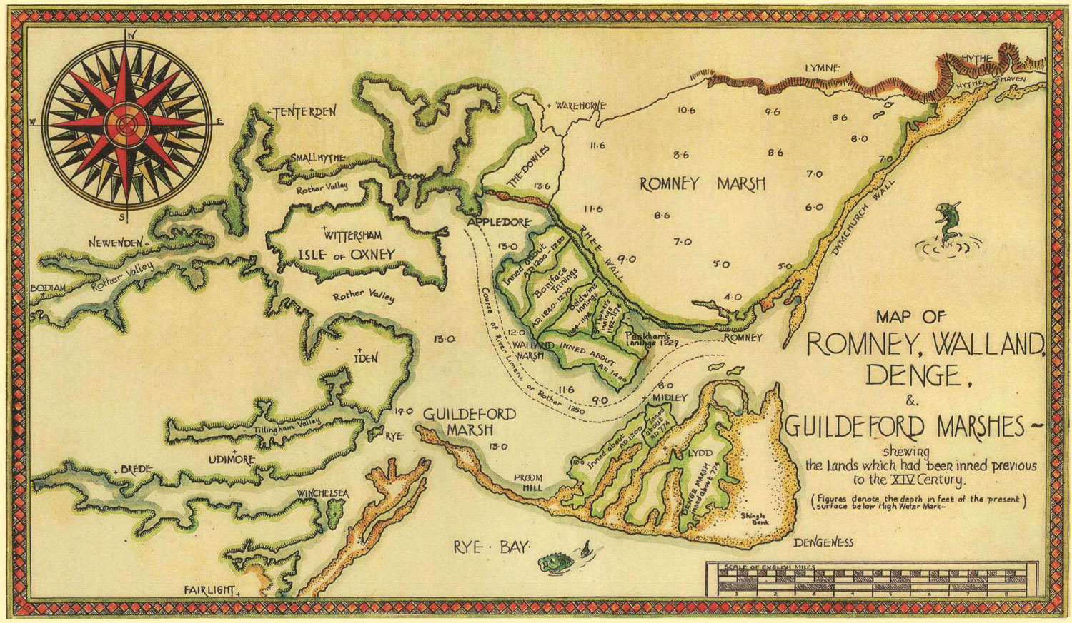

(An estimated map of the area in the late Tudor period. Small Hythe is just below Tenterden in the top-left-hand corner. © P L Kessler.) PARAGRAPH 1

It is not known when a chapel was first built in Small Hythe, but we do know that by the end of the fourteenth century a small chapel stood on the site of the current church. Very few records of this building remain, and so we know almost nothing about it. The material used, the dedication, or who served there. It is thought that it was licensed as a chapel to help ease the strain of the growing congregation of St Mildred’s in Tenterden. After many years of struggle between the residents of Small Hythe and the authorities, the village was given a license for their own chaplain who would be an extension of the vicarage of St Mildred’s in Tenterden.

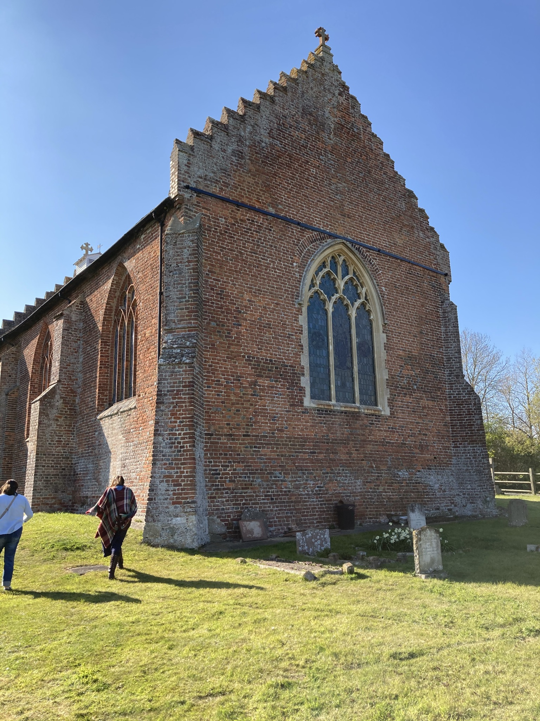(The view of the church from the south east. Note the stepped gables and heavy buttressing.) PARAGRAPH 2

However, only eight years after this in 1515, a fire tore through Small Hythe, taking the chapel and half of the village with it. After this the current chapel was constructed. Built of bricks, with distinctly Dutch looking, stepped gables at each end, it is believed that both the bricks and builders were sourced from the Low Countries. The church itself has a very plain design, with no aisles, chancels, or additionally alters. It does however have some beautiful and rare treasures inside. The wainscot paneling around the church is believed to be some of the oldest oak paneling anywhere. There are also some beautifully illuminated pieces along the walls of the church created by [Christopher St John](/20c/20c-st-john-biography), who lived with [Edith Craig](/20c/20c-craig-biography), the daughter of celebrated actress [Ellen Terry](/20c/20c-terry-biography).

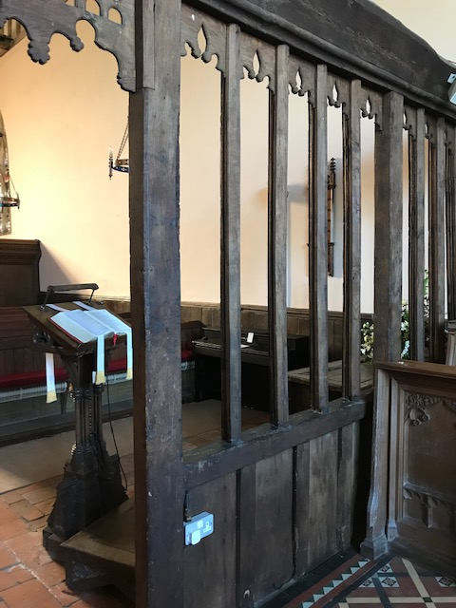(The view of the chancel screen and wainscotting from the high altar. Note how plain the carving is from this side of the screen, when viewed from the other side, it is highly decorative.) PARAGRAPH 3

[Terry](/20c/20c-terry-biography) lived in Small Hythe for nearly thirty years, and attended St John the Baptist’s as her parish church. She died on the 23rd of July, 1928, at the age of 81. Her funeral was a happy occasion, where the attendees wore summer dresses and sang the jollier hymns. She was cremated, and placed in a silver earn in the actor’s church, St Paul’s, Covent Garden.

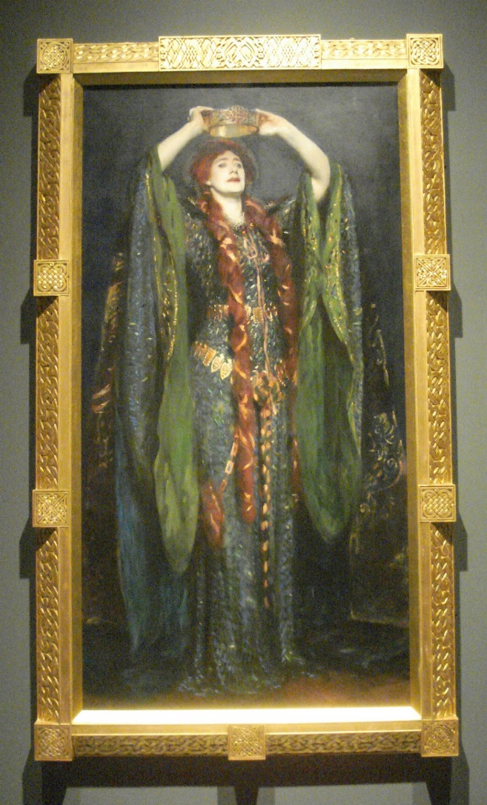(John Singer Sargent’s painting of Ellen Terry in her role as Lady Macbeth, which currently hangs in the Tate Britain in London.) PARAGRAPH 4

For such a small hamlet, Small Hythe has many attractions. [Small Hythe Place](https://www.nationaltrust.org.uk/smallhythe-place), preserved by the National Trust, the site of the medieval ship-building yards and dry-docks, and of course the church of St John the Baptist. An unusual yet homely chapel, with a lot to discover.

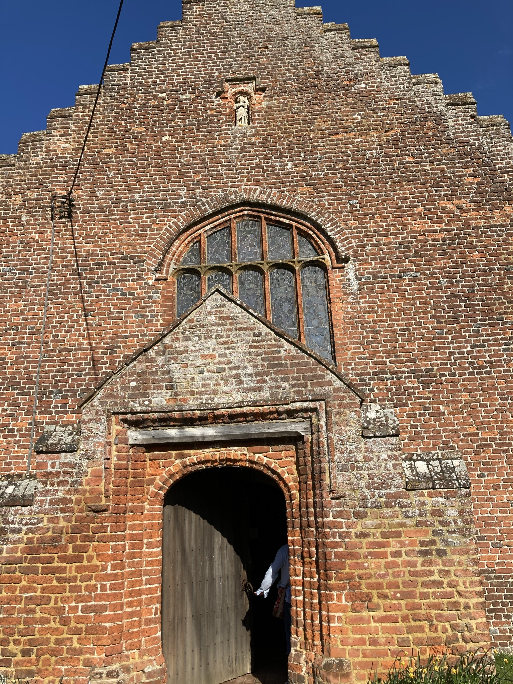(The view of the church from the west, showing the entrance and porch, as well as the figure of St John the Baptist set into a niche above the west window.) PARAGRAPH 5

**Article written by Andrew Vincent**

**Bibliography**:

* Zeleny, Rachael Baitch. “Painting an Ethos: The Actress, the Angel in the House, and Pre-Raphaelite Ellen Terry.” *Rhetoric Review*, vol. 32, no. 4, 2013, pp. 397–418., [www.jstor.org/stable/42003466. Accessed 29 April 2021](http://www.jstor.org/stable/42003466.%20Accessed%2029%20April%202021).
* THE BOOKLET FROM THE CHURCH HAS NO AUTHOR OR PRINTING INFORMATION BUT IT DOES HAVE A BIBLIOGRAPHY IN THE BACK, I AM UNSURE HOW TO REFERNCE IT.

1. It is here that I met Susannah Mayor, the Head Steward of Small Hythe Place. She gave me a personal tour of the site and taught me about the church and its connection to one of its most famous patrons.